Document Number | RP5
Document Title | Producing an invoice
Department Ownership | Reception
Document Type | Procedure
Department Owner | Alysia Harper and Angela Di Pardo
Document Author | Alysia Harper and Angela Di Pardo
Last Edited By | Derrick Chan | Lasted Edited On | 07/04/2015

Purpose

The Purpose of this procedure is to demonstrate to appropriate procedure to receive payment from patients and clients.

Scope

For all staff at the Health screening reception

Reference Documents

Billing Procedure

Definitions

Flowcharts (Other Images)

Procedures

Once the appointment has been billed In Genie an invoice can then be created to be sent to the company so that the payment can be processed.

- The appointment that has been billed needs to be selected. Check that the appointment has been billed correctly for all components of the assessment by comparing the booking form and the codes entered into genie (follow billing procedure).
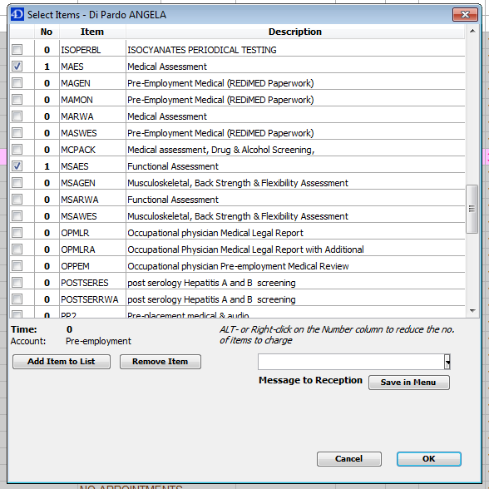

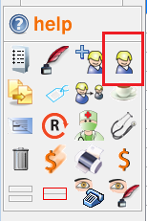
- You then need to double check that all the patient’s details have been entered into Genie, and making sure that all information is correct, and the information includes the employer and PO number. This can be checked by clicking on the blonde man.

- After the above is completed, you then need to ensure the patient’s name is selected/ highlighted. You will know when the candidates name is highlighted when there is black line around the candidate’s name. See below for an example.
When you have made sure that the name is highlighted, you can then click on the Dollar sign icon which is found in the panel on the left hand side of the screen.
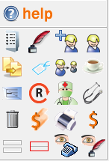

- When the Dollar sign is clicked, a pop-up window will appear (see below).
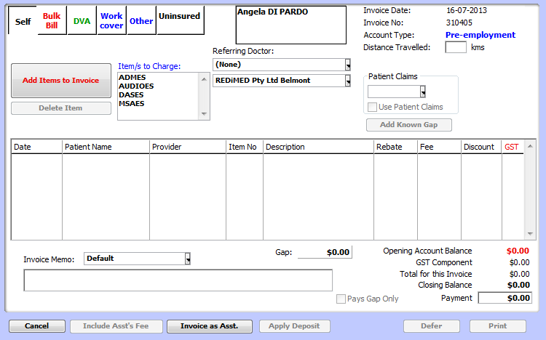

- Once this window appears you need to select the work cover box located on the top left hand corner (see above).

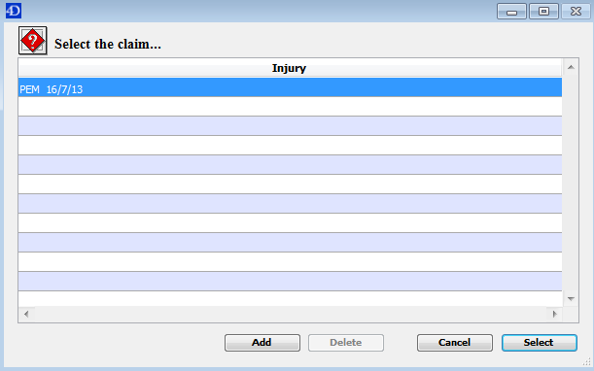
Once you do this a second window will appear (see below).

- Highlight the correct claim by selecting it you will then need to click select in the bottom right hand corner. (see above)
- After the claim has been selected another window will appear. The employer must always be selected.
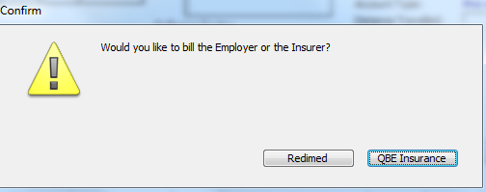
Note: Do not select the box with the name of the insurance company.

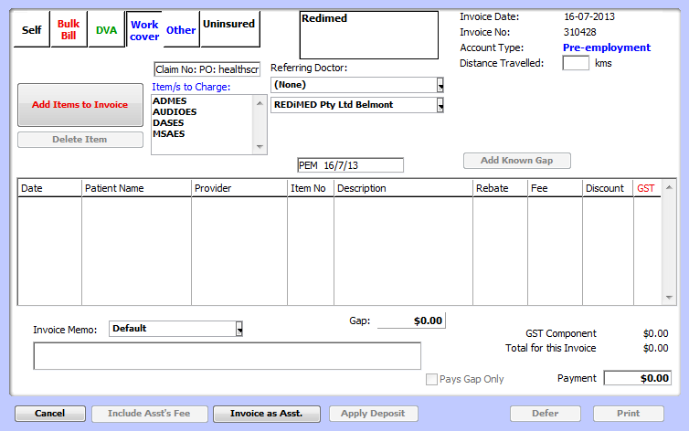
- Once you select the employer the original window will appear.

The claim number needs to be removed as this refers to worker compensation claims. For pre-employment medicals it should have just the PO: (see above)

- The codes that where entered during the billing process appear under the items to be charged, you should double check that all the assessments that where performed are on this list including the administration fee.
- Select the ‘add item to invoice’ box (see above). This action moves the item/s into the box below.
Note: Prices should appear under the Fee Colum and the GST box should always be ticked

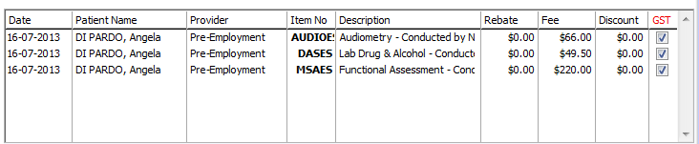

- Change the invoice memo: from default to Redimed.

- Once all above steps have been completed you can then select print in the bottom right corner of the window. This will print the invoice.

Appendices

